Module 4.2 Assignment
Initial Flowchart:
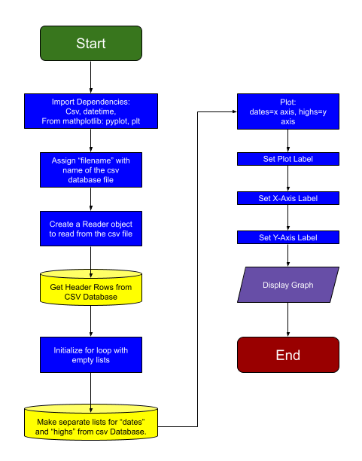
Final Flowchart
